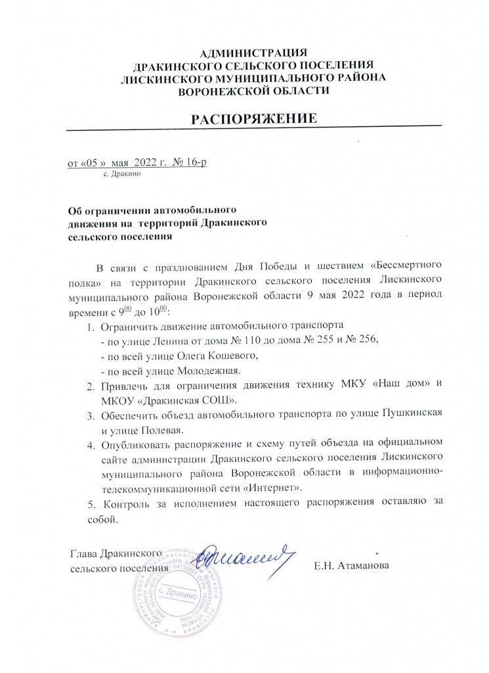

[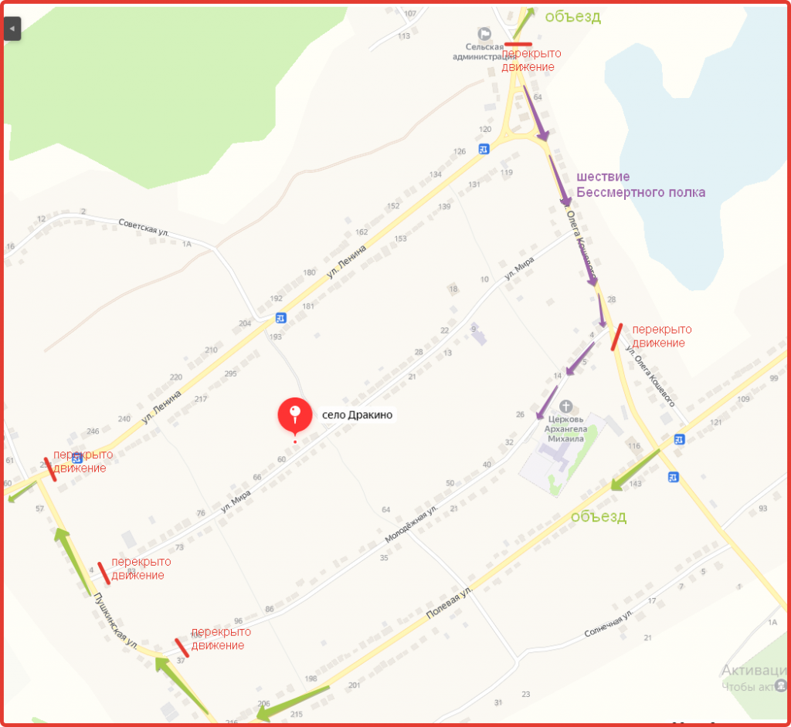](https://drakinskoe.muob.ru/upload/medialibrary/b6c/jzc6b6ri0bg60qyv3e6c6sq8mxt7tcg8.png)